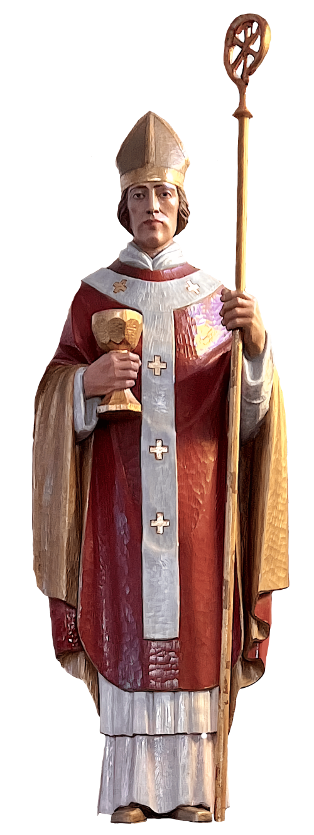

ST. NORBERT’S PARISH BULLETIN

100 Regent Road, North York, ON, M3K 1H3

[416.636.0213](tel:4166360213)

[stnorbertsno@archtoronto.org](mailto:stnorbertsno@archtoronto.org)

[www.stnorbertsno.archtoronto.org](http://www.stnorbertsno.archtoronto.org)



**PASTOR**

**Fr. Elissandro Caldas**

**ecaldas@archtoronto.org**

**SECRETARY**

**Raquel Reis**

**OFFICE HOURS**

**Monday**

Closed

**Tue – Wed - Fri**

9 am to 4 pm

**Lunchtime**12 pm to 1 pm

**Thursday**

9 am to 12 pm

**Saturday:**

Closed

**First and third Sundays**

**of each month**

10 am to 1pm

**Holidays**

Closed

____________________________________________________________________________________________________________________

**HOLY HOUR**

**First Friday of the month**

8:30 am Mass

**9 am to 11:30 am**

**5 pm to 8:30 pm**

7 pm mass



**MASS SCHEDULE**

**Tuesday & Wednesday**

7:00 pm

**Thursday & Friday**

8:30 am

**Saturday**

5:00 pm

**Sunday**

9:00 am (Italian)

10:30 am

12:00 pm

**RECONCILIATION**

Saturdays 4 pm – 4:30 pm

and upon appointment.

**RESERVED SEATING**

The first-row pews in the Church are for persons with special needs/disability and for ease when giving and receiving Holy Communion.

**NEW PARISHIONERS**

Please visit our website and download the fillable registration form. Once the form is completed, kindly submit it to the parish office.

**Schools associated with the Parish**

**ST. NORBERT** - 60 Maniza Road - 416-393-5309

**ST. ROBERT** - 70 Bainbridge Avenue - 416-393-5297

**MADONNA** - 20 Dubray Avenue - 416-393-5506

**SAINT VINCENT DE PAUL**

Please call – (416) 342-7590

RENOVATION PROGRAM

**Maintenance Collection (Blue envelope)**

NEW CHALLENGE

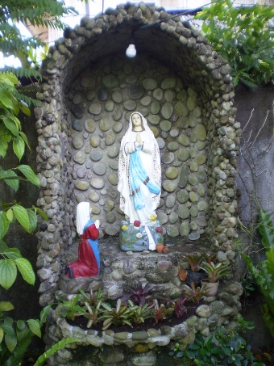The new challenge for us during this summer is to build a new grotto for Our Lady of Lourdes. After consulting a professional to renovate the old grotto and to repair the cracks, the conclusion is that it is more expensive to renovate it than to build a new one.

If you are one of those people who love to pray outside in front of the grotto or know anyone who could help with this project, please help us.

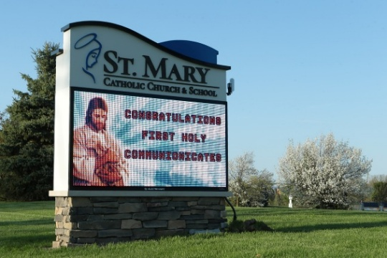In addition to this new place of prayer, it’s also our desire to have an LED sign for our parish to be displayed outside to help us advertise the mass schedule, the events, and also evangelize throughout our neighborhood.

These projects shall be done during the summer, as they require good weather. We will keep you posted about it. Thanks again for being part of this big project, and thanks for building our community.

NOTE: If you know any good masons, please refer them to the pastor.

WEDDING IN 2026

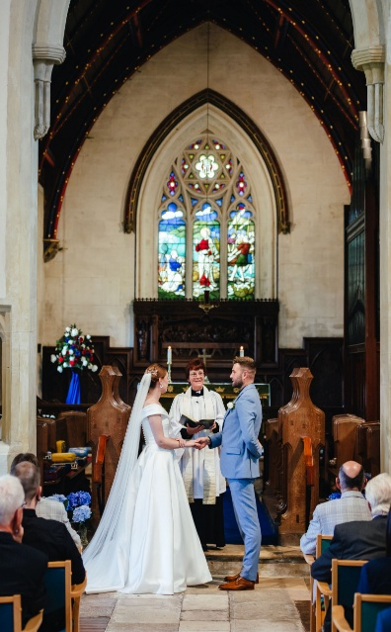Dear couples planning to marry in 2026, if you want to marry in our church, please schedule an appointment with the pastor. So we may begin to work on your marriage process.

According to the Archdiocese of Toronto, all couples must contact their parish at least a year before their wedding because marriage in the Church is a sacred sacrament.

PARISH INFORMATION SECTION

Dear Parishioners, if you wish to have your mass intention published in the parish bulletin, please submit it to the office by Wednesday at 12 p.m. After that date and time, your mass intention will be announced before mass, but it will not appear in the parish bulletin. Thanks.

**WORLD DAY FOR GRANDPARENTS AND THE ELDERLY**

**SUNDAY, 27 JULY 2025**

**Special Blessing at the end of the masses**



The fifth World Day for Grandparents and the Elderly will be celebrated this year on Sunday, July 27th 2025. Pope Francis instituted this World Day in 2021 to be celebrated by the universal Church every July, on or near the liturgical Memorial of Saints Joachim and Anne, grandparents of Jesus. This year’s theme is “*Blessed are those who have not lost hope*” (cf. Sir 14:2).

PARISH INFORMATION

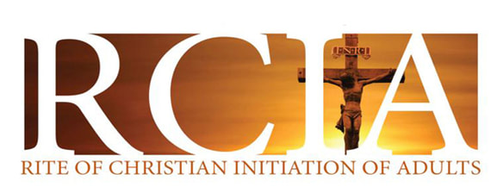Are you thinking about becoming a Catholic Christian?

The RCIA program is the right option for adults thinking about becoming a Christian Catholic. This course offers a good formation about the basis of the Catholic faith. If you are interested, stay tuned in our parish bulletin; registration starts in September.



|  |  |  |
| --- | --- | --- |
| **DATE** | **INTENTION** | **REQUESTED BY** |
| Sat, Jul 19  5 p.m. | + Thanksgiving for Rosa Bersabe | Rosa Bersabe |
| Sun, Jul 20  9 a.m. | + Sestilio & Romana Di Silvestre  + Beneditti Valentini | Family  Family |
| Sun, Jun 20  10:30 a.m. | For all Parishioners  (Pro Popolo) |  |
| Sun, Jul 20  12 p.m. | + Antonio Toniolo |  |
| Tue, Jul 22  7 p.m. | Available |  |
| Wed, Jul 23  7 p.m. | + Nino Nunzio Christopher Spensieri  + Deceased members of Toniolo & Lago Family | Family  Family |
| Thurs, Jul 24  8:30 a.m. | Available |  |
| Fri, Jul 25  8:30 a.m. | Available |  |

~~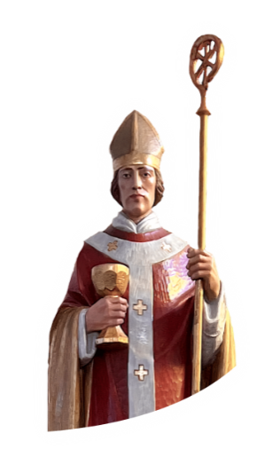~~**ST NORBERT'S FESTIVAL**

ON SEPTEMBER 07th, 2025

We invite you to save this date on your calendar to celebrate St. Norbert’s Festival together.

Tickets for the traditional BBQ are on sale before or after Mass.

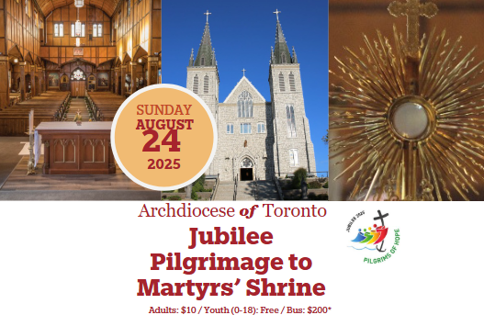JUBILEE PILGRIMAGE TO MARTYR’S SHRINE

During this Jubilee Year, on August 24, join us for a pilgrimage to the Martyrs’ Shrine, a national holy and historic space honoring the lives of the Canadian Martyrs.

**ANNUAL MASS FOR THE**

**FAITHFUL DEPARTED**

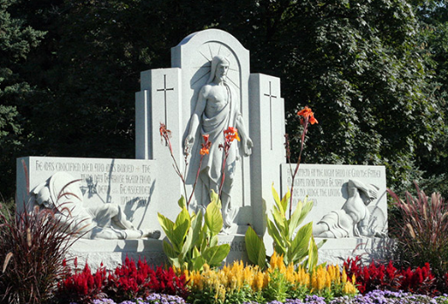Wednesday, August 13, 2025, at 7:00 p.m.

The Annual Mass for the Faithful Departed will be celebrated on Wednesday, August 13, 2025, at 7 p.m. Masses throughout the Greater Toronto Area and Barrie will take place for the souls of the deceased buried at our Catholic Cemeteries

DURING SUMMER

The Sunday bulletin will no longer be published throughout August.

|  |  |  |
| --- | --- | --- |
|  |  | **Westminster Funeral &**  **Reception Centre**   5826 Bathurst St.  North York, ON M2R 1Y6  Phone: (416) 665-2015  Fax: 1 866 841-3353   www.westminstercemetery.ca |
|  |  |  |

NOTICE

If you are interested to advertise your business here. Bring a cheque of $300 to St. Norbert’s Parish and all the information require.

For more information call the office on the regular days and hours of opening.

Catechism Registration will done in person in September. The parish will put online information and Forms to those who are interested.

The parish is accepting volunteers to help with catechism class, specially, those people who need reference letters at the end of the year.